Discussion Forums Sub-Team

What is your sub-team’s research goal and outcome that you aim to accomplish by the end of the Spring 2021 semester?
- Goal:
  - Automatically label comments with cognitive presence stage
  - A functional website to present the data from the data science side
- Outcome:

How is your sub-team currently managing the project? (Waterfall? Agile? Hybrid?)
We are currently managing the project using the agile method. We have a Trello board and have presentations every ~4 weeks.

Name: Morgan Powers
Specific Role: Project Manager
Primary Responsibilities:
- Maintain the Trello board
- Lead the presentations
- Monitor progress
- Lead meetings
- Create a timeline

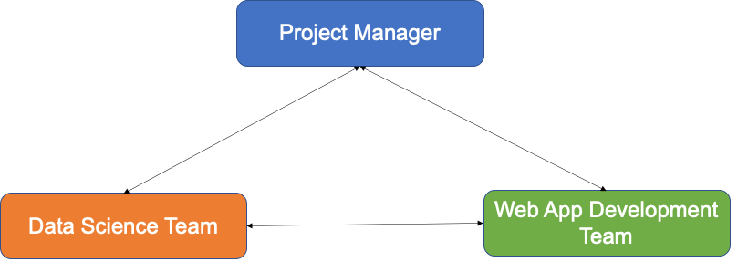

Name: Pratik Agarwal  Specific Role: Machine Learning Engineer  Primary Responsibilities: Automate classifying comments according to cognitive presence coding scheme and extend this analysis to apply to social presence using cohesion network analysis in an online course. |  | Name: Sambhav Jaideep  Specific Role: Front-End Web Developer  Primary Responsibilities:  - Set up structure of web-app  - Design appearance/functionality  - UX/UI
Name: David Kim  Specific Role: Machine Learning Engineer  Primary Responsibilities: Train a model to classify cognitive presence. |  | Name: Aanya Khandelwal  Specific Role:  Primary Responsibilities:
Name: Nidhi Pai  Specific Role: Data Scientist  Primary Responsibilities: explore metrics for models, create visualizations |  | Name:  Specific Role:  Primary Responsibilities:

